Image | 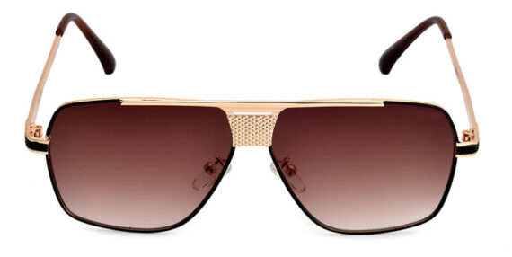
Brand | RAYBAN
Model Name | Bourne
Price | RS 1800
PRODUCT DETAILS

